## CHAPTER 1 INTRODUCTION

This introduction part contains overview of the domain, face recognition, proposed and existing systems and its advantages and disadvantages.

## OVERVIEW

Face recognition is a biometric software application. Biometric can be defined as the set of procedures which are used to measure the physical and behavioural traits of a person for identification and verification. A biometrics is, “An automated method of recognizing unique physical or behavioural characteristics of an individual”. Face Recognition basically figure out an individual in a digital image or video by analysing and comparing patterns. Recognition is widely and familiarly used and implemented in security systems like other biometrics procedures like eye iris or fingerprint recognition system. Face recognition a promising and popular research field in the pattern recognition and computer vision. Face Recognition supports security systems, surveillance, credit cards, passport, etc. Numerous methods have been suggested in the last few decades. The dimensions of the facial images are higher and thus need considerable amount of computing time for assortation. The classification and recognition time can be reduced by reducing dimensions of the image data. The facial recognition methodology infers mechanized systems to characterize facial segments that are the fundamental components of isolation. The mechanized strategies for facial recognition, despite the fact that seek after extremely well however don't watch subjects in the same way as a human cerebrum. The way people connect with other individuals solidly underpins the ability to remember them.

Contrasted and distinctive biometric applications and methodologies,facial recognition may not be the most solid and productive. Then again, one key point is that it doesn't seek the test's collaboration subject to satisfy. Appropriately outlined frameworks introduced in airplane terminals, multiplexes, and other open spots can distinguish people in group, without the attention to the passer in the framework. Different biometrics like fingerprints, iris sweeps, and discourse recognition can't perform this sort of recognizable proof. Be that as it may, inquiries a rised on the adequacy of facial recognition programming in the instances of railway, road and air terminal security. One of the primary parts of face distinguishing proof is its vigour. In contrast with different biometrics, a face recognition framework would permit a passer to be recognized by just strolling in front of a reconnaissance camera.

Face recognition is the process of recognizing/verifying a face given an image. There are two steps to do this,

* Detect a face in the image
* Recognize/verify the face using database

There are scores of algorithms that can be applied on an image to achieve these two steps. But each has its own down side. For one, many of these algorithms are computationally expensive and take a lot of time. The human face poses more problems than any normal object. This is primarily because; the human face comes in many forms, textures, features and colors. If we design an algorithm to detect a face, it has to be generic. It essentially needs to be one which is not constrained by the features of a human face. The basic steps of face recognition however, can be described in the block diagram given below.

Input Image

Pre-processing

Feature Extraction

Classification

## Figure 1.1 Process of Face Recognition

In every image processing System, input is taken as either video or image this field is called as input image. After accepting this input image ,image can be given under the feature extraction process. In this feature extraction process, image can be shrinked and expanded to get a minute features from the given image. Then the image can be classified by using any of the classifier available in the image processing application.

## DOMAIN-IMAGE PROCESSING

Image processing is any form of signal processing for which the input is an image, such as a photograph or video frame; the output of image processing may be either an image or a set of characteristics or parameters related to the image. Most image-processing techniques involve treating the image as a dimensional signal and applying standard signal-processing techniques to it.

Image processing usually refers to digital image processing, but optical and analog image processing also are possible. This article is about general techniques that apply to all of them. The acquisition of images (producing the input image in the first place) is referred to as imaging

Image processing allows one to enhance image features of interest while attenuating detail irrelevant to a given application, and then extract useful information about the scene from the enhanced image. This introduction is a practical guide to the challenges, and the hardware and algorithms used to meet them.

An image is digitized to convert it to a form which can be stored in a computer's memory or on some form of storage media such as a hard disk or CD-ROM.Image processing operations can be roughly divided into three major categories: Image Compression, Image Enhancement and Restoration, and Measurement Extraction.

Image compression is familiar to most people. It involves reducing the amount of memory needed to store a digital image. Once the image is in good condition, the Measurement Extraction operations can be used to obtain useful information from the image.

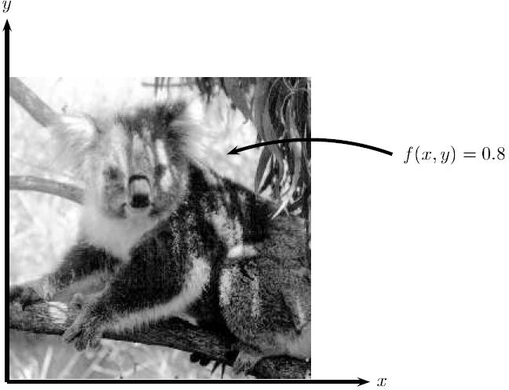

## Figure-1.2 Gray scale Image

Gray scale image can be represented only in the shades of gray. It can also be represented a number between 0-255.

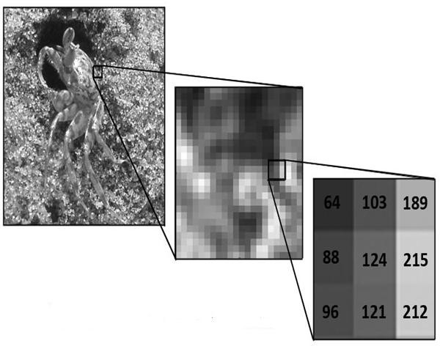

**Figure1.3 Gray scale image structure**

This means that each pixel in the image is stored as a number between 0 to 255, where 0 represents a black pixel, 255 represents a white pixel and values in- between represent shades of gray.

## FACE RECOGNITION

Face recognition is a biometric software application that can identify a specific individual in a digital image by analyzing and comparing pattern. A facial recognition system is a technology capable of identifying or verifying a person from a digital image or video frame from a video source. There are multiple methods in which facial recognition system work, but in general, they work by comparing selected facial features from given image with faces within a database.

Closely related to image processing are computer graphics and computer vision. In computer graphics, images are manually made from physical models of objects, environments, and lighting, instead of being acquired from natural scenes, as in most animated movies. Computer vision, on the other hand, is often considered high-level image processing out of which a machine/computer/software intends to decipher the physical contents of an image or a sequence of images.

## SCOPE OF WORK

In this project, we develop an effective but very simple PCA algorithm which is based on the creation of the low dimensional representation of the whole face i.e. Eigenface. Be that as it may, inquiries a rised on the adequacy of facial recognition programming in the instances of railway, road and air security. One of the primary parts of face distinguishing proof is its vigour. In these algorithm we are selecting the Principal Component by using Eigenvectors [2] having the greater value of Eigenvalue. After this the DWT based sub-band system is going to be applied on the PCA.

## PROBLEM DEFINITION

Our objective of this project is to detect the perfect face features. Using those features as an input to the classifier, we can identify whether the particular face in a large image database is available or not. If we find the exact face, then need to reply 1 else 0.

## PROBLEM ANALYSIS

The purpose of the System Analysis is to produce the brief analysis task and also to establish complete information about the concept, behavior and other constraints such as performance measure and system optimization. The goal of System Analysis is to completely specify the technical details for the main concept in a concise and unambiguous manner.

## EXISTING METHOD

The existing system consists a modified Convolutional Neural Network (CNN) architecture by adding two normalization operations to two of the layers. The normalization operation which is batch normalization provided acceleration of the network. CNN architecture was employed to extract distinctive face features and Soft-max classifier was used to classify faces in the fully connected layer of CNN. In the experiment part, Georgia Tech Database showed that the proposed approach has improved the face recognition performance with better recognition results.

## DISADVANTAGES OF EXISTING METHOD

Convolutional Neural Network (CNN) based face recognition using SIFT algorithm for feature extraction and acquires a transformed face image to raise the features.Demerits are,

* + - * The overlapping creates complexity due to different dimensions of both images.
      * Time consuming process.
      * The results has lower accuracy, precision and sensitivity than face recognition using different feature extractors.

## PROPOSED SYSTEM

In our proposed method of face detection technique, DWT (Discrete wavelet Transform), PCA (Principal Component Analysis) and SVM (Support Vector Machine) classifier are used. DWT is used for extract the feature from faces. This DWT feature will possess the low frequency components sub-band called as LL-sub-band which carries significant information, is considered for further decomposition. PCA is a standard technique use for dimensionality reduction in which face data can analyze and observation can be described by several intercorrelated dependent variables. The SVM classifiers are then applied to these extracted features to classify the input images. So this proposed system will increases the face identification rate.

## ADVANTAGES OF PROPOSED SYSTEM

* SVM classifier used for classification of tumor type. Support Vector Machines (SVM) and its derivations have recently obtained state-of-the- art results in challenging large databases.
* DWT+PCA and GLCM algorithms used for feature extraction. In which the DWT Algorithm decomposes an image into a set of basic functions called wavelets

## CHAPTER 2 LITERATURE SURVEY

In propose methodology of face detection technique, DWT (Discrete wavelet Transform), PCA (Principal Component Analysis) and SVM (Support Vector Machine) classifier. DWT is used for extract the feature from faces. This DWT feature will possess the low frequency components sub-band called as LL-sub- band which carries significant information, is considered for further decomposition. PCA is a standard technique use for dimensionality reduction in which face data can analyze and observation can be described by several inter- correlated dependent variables. The SVM classifiers are then applied to these extracted features to classify the input images. So this proposed system will increases the face identification rate.

Alaa Eleyan, Hasan Demirel et. al.,(2010) designed that Co-Occurrence based Statistical Approach for Face Recognition. This paper introduces a new face recognition method based on the gray-level co-occurrence matrix (GLCM). Both distributions of the intensities and information about relative position of neighbourhood pixels are carried by GLCM. Two methods have been used to extract feature vectors from the GLCM for face classification. The first, method extracts the well-known Haralick features to form the feature vector, where the second method directly uses GLCM by converting the matrix into a vector which can be used as a feature vector for the classification process. The results demonstrate that using the GLCM directly as the feature vector in the recognition process outperforms the feature vector containing the statistical Haralick features. Additionally, the proposed GLCM based face recognition system outperforms the well known techniques such as principal component analysis and linear discriminant analysis.

Chengliang Wang, Libin Lan, Yuwei Zhang, Minjie Gu et. al.,(2006) designed that Face Recognition Based on Principle Component Analysis and Support Vector Machine.Face recognition is an important research field of pattern recognition. Up to now, it caused researchers great concern from these fields, such as pattern recognition, computer vision, and physiology, and so on. Various recognition algorithms have been proposed. Therefore, it is necessary for us to pay close attention to feature extractor and classifier. In this paper, in order to raise recognition rate, Principle Component Analysis (PCA) is used to extract image feature, and Support Vector Machine (SVM) is used to deal with face recognition problem. SVM has been recently proposed as a new classifier for pattern recognition. We take Principle Component Analysis & Support Vector Machine (PCA&SVM) to do experiments on the Cambridge ORL Face database, and compare this method with Principle Component Analysis & Nearest Neighbor (PCA&NN) and Support Vector Machine (SVM) on recognition rate and recognition time respectively. Finally, this experimental results show that recognition rate of this method, under small samples circumstance, is better than other two methods. It shows that, for face recognition, sending PCA features to SVM classifiers is feasible and correct.

Liu Song and Luo Min et. al.,(2009) designed that Face Recognition Based on 2DPCA and DWT. A face recognition method based on two dimension principle component analysis and Discrete Wavelet Transform is proposed. We compared our methods with three face recognition algorithms, PCA, Wavelet+ PCA and 2DPCA.in the experiments, the nearest neighbour classifier is used to recognize different faces from the ORL face database. Experimental results show that the proposed method improved the recognition rate effectively in comparison with other three method, the best accuracy rate can reach 93%.

S.V.Tathe, A.S.Narote and S.P.Narote et. al.,(2012) designed that Human Face Detection and Recognition in Videoes. Advancement in computer technology has made possible to evoke new video processing applications in ﬁeld of biometric face detection and recognition. Applications includes are face detection and recognition integrated to surveillance systems, gesture analysis etc. The ﬁrst step in practical face analysis systems is real-time detection of face in sequential frames containing face and complex objects in background. In this paper a system is proposed for human face detection and recognition in videos. Efforts are made to minimize processing time for detection and recognition processes. To reduce human intervention and increase overall system efﬁciency the system is segregated into three stages- motion detection, face detection and recognition. Motion detection reduces the search area and processing complexity of systems.

Kaihao Zhang, Yongzhen Huang and Liang Wang et. al.,(2006) proposed that Facial Expression Recognition Based on Deep Evolutional Spatial- Temporal Networks. One key challenging issue of facial expression recognition is to capture the dynamic variation of facial physical structure from videos. In this paper, we propose a part-based hierarchical bidirectional recurrent neural network (PHRNN) to analyze the facial expression information of temporal sequences. Our PHRNN models facial morphological variations and dynamical evolution of expressions, which is effective to extract “temporal features” based on facial landmarks (geometry information) from consecutive frames. Meanwhile, in order to complement the still appearance information, a multi- signal convolutional neural network (MSCNN) is proposed to extract “spatial features” from still frames. We use both recognition and veriﬁcation signals as supervision to calculate different loss functions, which are helpful to increase the variations of different expressions and reduce the differences among identical expressions. This deep evolutional spatial-temporal network

(composed of PHRNN and MSCNN) extracts the partial-whole, geometry- appearance, and dynamic-still information, effectively boosting the performance of facial expression recognition. Experimental results show that this method largely outperforms the state-of-the-art ones. On three widely used facial expression databases (CK+, Oulu-CASIA, and MMI), our method reduces the error rates of the previous best ones by 45.5%, 25.8%, and 24.4%, respectively.

S. K. Kim et. al.,(2009) designed that extracting a license plate is an important stage in the automatic vehicle identification. It is very difficult because vehicle images are usually degraded and processing the images is computationally intensive. In this paper, we propose a new method to extract the plate region using a distributed genetic algorithm. The algorithm offers robustness in dealing with deformation of vehicle images and inherent parallelism to improve processing time. A test with seventy images shows an extraction rate of 92.8% working well with the real world situations. This results suggest that the proposed method is pertinent to be put into practical use. An algorithm is adapted into the solution for parking management system. The solution then is implemented as proof of concept to the algorithm[20].

M. I. Chacon et. al.,(2010) designed that a new dynamic ATR, automatic target recognition, scheme based on a Pulse Coupled Neural Network, PCNN, The PCNN is used to generate candidate regions that may contain a license car plate. Candidate regions are generated from pulsed images, output of the PCNN network. Statistics of the Fourier transform are used to determine if a candidate region contains a license plate. If the license plate is not located in the set of candidate regions, the PCNN network parameters are adjusted to generate new regions. The PCNN network pulses again to generate a new pulsed image and new candidate regions are eroded and analyzed. The proposed system is robust in the sense that it does not restrict the location of the plate. neither the illumination conditions when the image is acquired. The purpose of no

restrictions is to evaluate the proposed system under Conditions where a person can succeed. The system performance was 85% on a set of images. One advantage of the proposed scheme is that it must be adapted to solve ATR problems[8].

S. Z. Wang et. al.,(2008) designed that an approach to develop an automatic license plate recognition system. Car imager are taken from various positions outdoors. Because of the variations of angles from the camera to the car, license plates have various locations and rotation angles in an image. In the lierase plate detection phase, themagnisde of thevertical gradients is used to detect candidate license plate regions. Thcsc candidate regions are then evaluated based on three geometrical features: the ratio of width and height, the size and the orientation. The last feature is defined by the major axis. In the character recognition phase, we must detect character features that are non- sensitive to the rotalion variations. The various rotated character images of a specific character can be normalized to the same orientation based on Ihc major axis of the character image. The crossing counts and peripheral background area of an input character image are selected 8s the features for rotation-free character rccognition. Experimental results show that lhc license plates detection method can correctly extract all license plates from 102 car images taken outdoors and the rotation-free character recognition method can achieve an accuracy rate of 98.6%[28].

S.-L. Chang et. al.,(2005) designed that License plate recognition (LPR) technology is a currently more popular pattern recognition processing technology, which has broad application prospects. In this chapter, based on the original LPR technology, a novel method of LPR based on the Sobel operator is presented. We improve the accuracy of LPR by establishing an eight-direction template, and the test results show that our improved algorithm is effective.

Then we use the k-means algorithm for character segmentation of license plate to get the better license plate image segmentation[9].

I.D. Psoroulas et. al.,(2012) designed that License plate recognition (LPR) algorithms in images or videos are generally composed of the following three processing steps: extraction of a license plate region; segmentation of the plate characters; and recognition of each character. This task is quite challenging due to the diversity of plate formats and the non uniform outdoor illumination conditions during image acquisition. Numerous techniques have been developed for LPR in still images or video sequences, and the purpose of this paper is to categorize and assess them. Issues such as processing time, computational power, and recognition rate are also addressed, when available. Finally, this paper offers to researchers a link to a public image database to define a common reference point for LPR algorithmic assessments[3].

L. Carrera et. al.,(2010) designed that a new method for license plate detection using neural networks in gray scale images. The method proposes a multiple classification strategy based on a Multilayer Perceptron. It consists of many classifications of one image using several shifted window grids. If a pixel belongs or not to the license plate is determined by the most frequent answer given by the different classifications. The result becomes more precise by means of morphological operations and heuristic rules related to shape and size of the license plate zone. The whole method detects the license plates precisely with a low error rate under non-controlled environments [7].

1. W. Lim et .al.,(2014) designed that we present a license plate detector using a fusion of Maximally Stable Extremal Regions (MSER) and SIFTbased unigram classifier trained with Core Vector Machine (CVM). First, MSER is used to obtain a set of regions. Highly unlikely regions are removed with a simplistic heuristic-based filter. Finally, remaining regions with sufficient

positively classified SIFT key point are retained as likely license plate regions. To train the unigram classifier, a set of SIFT keypoints are obtained from a small set of ground truth images where the license plates are labeled. The training of the SIFT-based unigram classifier is found to be optimal when a CVM is used. On our testing data set, we got a recall rate of 0.98 and a precision rate of 0.964641. On the Caltech Cars (Rear) data set, a recall rate of 0.904762 and precision rate of 0.837349 is obtained [23].

1. Zhang et. al.,(2009) designed that a robust vehicle license plate detection algorithm based on multi-features, including mathematical morphology, rectangle features, edge statistics and characters features. Here we utilize the word “robust” to describe the designed that algorithm because it is not only adaptive to variance occasions, such as variance of the illumination, vehicle position, the color, both background and foreground, the acclivitous angle and the size while working in different complex environment, but also can be used in several regional license plates while some other algorithms just work well for one region and badly for another. We have used the algorithm for detecting both American and Chinese plates and gotten a good performance in both regions. Those are the two primary contributions of the algorithm. Another contribution is that we use a character feature verification algorithm to determine the final detection result in the candidate rectangles. This is proved to be more effective than other features [30].

H. Anoual et. al., (2011) designed that there is a need to identify vehicle license plates (VLP) in images taken from a camera that is far away from the vehicle for security. The extracted information from vehicle license plates is used for enforcement, access-control, and flow management, e.g. to keep a time record for automatic payment calculations or to fight against crime. That’s make license plates detection crucial and inevitable in the vehicle license plate recognition system. This paper aims to present a new robust method to detect

and localize license plates in images. Especially we focus on the Moroccan’s VLP. The designed that approach is based on edge features and characteristics of license plate’s characters. Various images including Moroccan’s VLP taken from different distances and under different angles were used to evaluate the designed that method. The experimental results show that our system can efficiently detect and localize the Moroccan’s VLP in the images. Indeed, the recall/precision curve of the designed that method proves that 95% precision rate is obtained for recall rate value equals to 81%. In addition, the standard measure of quality is equal to 87.44 % [4].

S. Kranthi et. al.,(2011) designed that Automatic recognition of car license plate number became a very important in our daily life because of the unlimited increase of cars and transportation systems which make it impossible to be fully managed and monitored by humans, examples are so many like traffic monitoring, tracking stolen cars, managing parking toll, red-light violation enforcement, border and customs checkpoints. This paper mainly introduces an Automatic Number Plate Recognition System (ANPR) using Morphological operations, Histogram manipulation and Edge detection Techniques for plate localization and characters segmentation. Artificial Neural Networks are used for character classification and recognition[21].

P. Reshma et. al.,(2012) designed that Noise removal method is used to pre process the input image and blob detection method is used to localize and segment Indian number plates. The segmented characters on the number plate region are compared with the previously stored character database and finally approve authentication or access permission for different vehicles. The designed that approach divides the whole system into five modules. First module deals with image acquisition and preprocessing of input images. The second module concentrates on detection of number plate region from the different identified blobs. A classification algorithm is used to differentiate the other blobs from

license plate region. The third module is all about segmentation of each alpha numeric characters present in the localized number plate region and fourth module proceeds towards recognizing the number plate. Finally a validation module is incorporated to provide authentication of identified vehicles[27].

1. Ibrahim et. al.,(2013) designed that Automatic license plate recognition (ALPR) is the extraction of vehicle license plate information from an image or a sequence of images. The extracted information can be used with or without a database in many applications, such as electronic payment systems (toll payment, parking fee payment), and freeway and arterial monitoring systems for traffic surveillance. The ALPR uses either a color, black and white, or infrared camera to take images. The quality of the acquired images is a major factor in the success of the ALPR. ALPR as a real-life application has to quickly and successfully process license plates under different environmental conditions, such as indoors, outdoors, day or night time. We categorize different ALPR techniques according to the features they used for each stage, and compare them in terms of pros, cons, recognition accuracy, and processing speed. Future forecasts of ALPR are given at the end[14].
2. K. Ibrahim et. al.,(2014) designed that most vehicle license plate recognition use neural network techniques to enhance its computing capability. The image of the vehicle license plate is captured and processed to produce a textual output for further processing. This paper reviews image processing and neural network techniques applied at different stages which are preprocessing, filtering, feature extraction, segmentation and recognition in such way to remove the noise of the image, to enhance the image quality and to expedite the computing process by converting the characters in the image into respective text. An algorithm is adapted into the solution for parking management system. The solution then is implemented as proof of concept to the algorithm [15].

Bhonsale Tejas et. al.,(2017) designed that the police forces around the world use vehicle number plate for legal vehicle authorization purposes, to check if a vehicle is registered or licensed. Most of us keep the vehicle papers in the vehicle itself, which is not at all safe in case of theft. In today's world, it is not secure to carry our vehicle papers and wherever we go. Hence, a system must be designed in which it is not necessary to carry our important documents to each and every place for verification. The aim is to design a system which captures the image of the number plate of a vehicle using a camera and the details are being retrieved using the character segmentation which is done by a feature extraction optical character recognition algorithm (OCR). Then the details retrieved from the number plate in text format is used to extract all the important information of the vehicle like, the name of the owner, address of the owner, date of registration of the vehicle etc. from the database. The police can verify whether the documents are fake or not. For us, it is useful as we do not have to carry our documents to every place with the fear of losing them [6].

Madhu Shree et. al.,(2017) designed that in today's image centric world image processing has become the centre of attention for various real-life applications. Embarking from car thefts, breaking traffic rules to contravene restricted expanse, Image Processing has given us a conviction to put a grinding halt to these malpractices. Inspired by the feature learning capabilities of Convolution Neural Networks (CNN), the preeminent work is the detection and recognition of the car plate number image which is accomplished by dint of Convolution Neural Network (CNN). The number plate images can be procured by a still camera. Self synthesized feature of CNN is capable of recognizing the states of the vehicle from the number plate with a reasonably high accuracy of 90% even with very low training size. CNN has proved its robustness even with distorted, tilted and illuminated datasets[24].

Rajshekhar Mukherjee et. al.,(2012) designed that the implementation of a character feature extraction, classiﬁer and an effective mapping algorithm applied on images of vehicle license plates, using nonlinear feature extraction and spatial mapping. A novel algorithm for low-level visual feature extraction has been presented, highlighting non-linear morphological operations with structuring, ﬁltering, erosion and dilation techniques. Filtering and enhancement of raw image for key feature extraction and recognition by edges by sobel, canny and Fuzzy logic, convolution, median ﬁltering and scaling image for boosting visual spatial features has been performed. Template matching using thresholding by effective feature mapping and semantic feature matching methods with pre-fed datasets has been accomplished as an application to image computing. The results obtained are tabulated and an accuracy of 79.30% using the above mentioned algorithm is reported. Comparison methodologies used are MSE and PSNR values and Structured Similarity Index (SSIM). The accuracy of results thus obtained are reported, suggesting the robustness and effectiveness of the algorithm. Image acquisition is accomplished by a remotely controlled android platform based device integrated with the MATLAB platform in real-time. The acquired number-plate data is transferred into a text ﬁle for creating a vehicle index log, critical for security systems [26].

S.-L. Chang et. al.,(2004) designed that License plate recognition (LPR) technology is a currently more popular pattern recognition processing technology, which has broad application prospects. In this chapter, based on the original LPR technology, a novel method of LPR based on the Sobel operator is presented. We improve the accuracy of LPR by establishing an eight-direction template, and the test results show that our improved algorithm is effective. Then we use the k-means algorithm for character segmentation of license plate to get the better license plate image segmentation.

## CHAPTER 3 SYSTEM DESIGN

In system design a general description about the module and various components used along with their corresponding diagrammatic representation using UML are discussed.

## DESIGN REPRESENTATION

The design can be represented by means of UML diagrams. In this, We are going to represent the design by using unified modeling language.

## UNIFIED MODELLING LANGUAGE

UML is a standard language for specifying, visualizing and documenting of software system and created by object management group (OMG) in 1997. There are three types of modelling : structural model, behavioural model, and architectural model. To model a system the most important aspect is to capture the dynamic behaviour which has some internal or external factors for making the interactions. These internal or external agents are known actors. It consists of actors, use cases and their relationship among several other useful and important features. The UML diagrams are,

* + - * Flow diagram
      * Use Case Diagram
      * Component Diagram

## USE CASE DIAGRAM

A use case illustrates a unit of functionality provided by the system. The main purpose of use case diagram is to help development teams visualize the

functional requirements of a system, including the relationship of “actors” to essential processes, as well as the relationship among different use cases.



System



Image

Pre-processing

Feature Extraction

User

Classification

Matching

## Figure 3.1 Use case diagram for face recognition

User and system are the two actor’s used in this figure3.1 use case diagram. The user will do the process of capturing the image then it will scan the image. The scanned image will get filtered. The filtered image will get enhanced. Then the image extracted in order to convert it from image to text.

## FLOW DIAGRAM

Users are able to visualize how the system will operate, what the system will accomplish, and how the system will be implemented is represented in figure 3.2 Flow diagram is a collective term for a diagram representing a flow or set of dynamic relationships in a system.



Image Input

Pre-processing

Feature Extraction

Classification

Matching

## Figure 3.2 Flow diagram for face recognition

The term flow diagram is also used as a synonym for flowchart, and sometimes as a counterpart of the flowchart.

## COMPONENT DIAGRAM

A component diagram displays the structural relationship of components of a software system. These are mostly used when working with complex systems that has many components such as sensor nodes, cluster head and base station.

Input Image

Pre-processing

Feature

Extraction

Matching

Classification

## Figure 3.3 Component diagram for face recognition

**CHAPTER 4 SYSTEM ARCHITECTURE**

In this system Architecture diagram, flow of the total face recognition process will be explained.

## ARCHITECTURE DIAGRAM

**PRE-PROCESSING EXTRACTION**

INPUT IMAGE

RGB TO GRAY SCALE CONVERSION

FACE DETECTION(CROPPING)



DWT

PCA

GLCM

CLASSIFY

DATASET

(SVM)

RESULT

**Figure 4.1 System Architecture**

In figure 4.1 System Architecture, shows that pre-processing step contains two processes such as RGB conversion and cropping. And also explains that Feature extraction uses three algorithms such as DWT, PCA, GLCM.

# Input image database

The average size of the faces available in these images is 150×150 dimensions and pixels.The images shows frontal and/or tilted face with different facial expressions, lighting conditions and scale. All of the face regions in the images in the database were resized as 82×94.

# Pre-processing

This step is important as acquired image is noisy. The pre-processing includes series of operations performed on acquired input finger vein image. Each of the acquired finger-vein images is first subjected to binarization . A binary image is a digital image that has only two possible values for each pixel

i.e. 1 and 0.Using a fixed threshold value, to coarsely localize the finger shape in the images.

# Feature Extraction

The Discrete Wavelet Transform (DWT) is a very popular and commonly used transform for image processing. GLCM creates a matrix with the directions and distances between pixels, and then extracts meaningful statistics from the matrix as texture features. It quantificationally describes the texture feature.

ROI (REGION OF INTEREST) is used to get only important region of a finger vein image, by elimination unwanted background details, as result less time is consumed in processing. The resulting binary mask obtained from above step is used to segment the ROI from the original finger-vein image

# Classifier

Support Vector Machines (SVM) and its derivations have recently obtained state-of-the-art results in challenging large databases. In our system, matching is carried out after training the system, the aim of matching is to evaluate the similarity between the testing image and the stored templates.

Regarding the learning algorithm, several approaches have been designed that, including, among others, neural networks and their invariant, Support Vector Machines (SVM) / Support Vector Regressors (SVR), Random Forests (RF), and projection techniques such as Canonical Correlation Analysis (CCA)… From the wide variety of learning schemes presented in the literature, Support Vector Machines (SVM) and its derivations have recently obtained state-of-the-art results in challenging large databases.

In our system, matching is carried out after training the system, the aim of matching is to evaluate the similarity between the testing image and the stored templates; giving a new image ξ considered as a test example.

First, we build its 1D representation (the template) using the feature extraction method designed that in this work. Next, we use the SVM to classify the image ξ to the corresponding class.

The type of the SVM used for classification is: SVM with RBF kernel, we select the most widely used kernel function, i.e., RBF (Radius Basis Function). The parameter in the RBF kernel function was empirically selected in this paper (γ = 0.0001).

## CHAPTER 5 SYSTEM IMPLEMENTATION

Implementation is the stage of a project during which theory is turned into practice. The major steps involved in this phase are, Acquisition and Installation of Hardware and Software Conversion user training documentation. The hardware and the relevant software required for running the system must be made fully operational before implementation.

## ALGORITHM

In our proposed system, we are going to use many face recognition algorithms like DWT, PCA, GLCM.

## DISCRETE WAVELET TRANSFORM(DWT)

The Discrete Wavelet Transform (DWT) is a very popular and commonly used transform for image processing. The DWT decomposes an image into a set of basic functions called wavelets; decomposition is defined as the “resolution” of an image. The DWT then performs a multi-resolution analysis of a signal with localization in both time and frequency domains. 2D-DWT is implemented as a set of filter banks, comprising of a cascaded scheme of high-pass and low- pass filters. The final result obtained is a decomposition of the input image into four non-overlapping multi-resolution sub- bands: LL, LH, HL and HH. The sub-band LL represents the coarse-scale DWT coefficients while the sub-bands LH, HL and HH represent the fine-scale of DWT coefficients. In this work HH is explored for face recognition.

## PRINCIPAL COMPONENT ANALYSIS(PCA)

Principal component analysis (PCA) for face recognition is based on the information theory approach. It extracted the relevant information in a face image and encoded as efficiently as possible. It identifies the subspace of the

image space spanned by the training face image data and decorrelates the pixel values. The classical representation of a face image is obtained by projecting it to the coordinate system defined by the principal components. The projection of face images into the principal component subspace, achieves information compression, decorrelation and dimensionality reduction to facilitate decision making. In mathematical terms, the principal components of the distribution of faces or the eigenvectors of the covariance matrix of the set of face images, is sought by treating an image as a vector in a very high dimensional face space.

## GRAY LEVEL CO-OCCURRENCE MATRIX(GLCM)

In our proposed System, we are going to use texture based feature extraction based on GLCM.

GLCM creates a matrix with the directions and distances between pixels, and then extracts meaningful statistics from the matrix as texture features. Commonly used features of texture in GLCM are shown as follows. GLCM expresses the texture feature according the Correlation of the couple pixels gray-level at different positions. It quantificationally describes the texture feature. In this paper, four features is selected, include energy, contrast, correlation and homogeneity.

Energy is given by,



It is a gray-scale image texture measure of homogeneity changing, reflecting the distribution of image gray-scale uniformity of weight and texture.

Contrast is given by,



Contrast is the main diagonal near the moment of Inertia, which measure the value of the matrix is distributed and images of local changes in number, reflecting the image clarity and texture of shadow depth. Contrast is large means texture is deeper.

Correlation is given by,



A statistical measure of how correlated pixel is to its neighbour over the whole image. Range = [-1 1]. Correlation is 1 or -1 for the perfectly positively or negatively correlated image. Correlation is Nan for a constant image.

Homogeneity is given by,



Closeness of distribution of elements in GLCM to the GLCM diagonal. Range = [0 1]. Homogeneity is one for a diagonal GLCM.

## SUPPORT VECTOR MACHINE(SVM)

Regarding the learning algorithm, several approaches have been designed that, including, among others, neural networks and their invariant, Support Vector Machines (SVM) / Support Vector Regressors (SVR), Random Forests (RF), and projection techniques such as Canonical Correlation Analysis (CCA)… From the wide variety of learning schemes presented in the literature, Support Vector Machines (SVM) and its derivations have recently obtained state-of-the-art results in challenging large databases.

In our system, matching is carried out after training the system, the aim of matching is to evaluate the similarity between the testing image and the stored templates; giving a new image ξ considered as a test example. First, we build its 1D representation (the template) using the feature extraction method designed

that in this work. Next, we use the SVM to classify the image ξ to the corresponding class. The type of the SVM used for classification is: SVM with RBF kernel, we select the most widely used kernel function, i.e., RBF (Radius Basis Function). The parameter in the RBF kernel function was empirically selected in this paper (γ = 0.0001).

## IMAGE DATABASE

The images show frontal and/or tilted face with different facial expressions, lighting conditions and scale. All of the face regions in the images in the database were resized as 82×94. Figure 5.1 presents some face images of different subjects from the GT database.

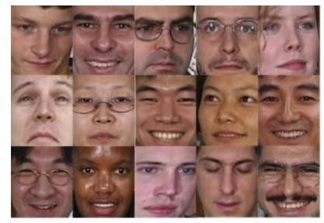

## Figure 5.1 Image Database

Georgia Tech face database contains images of 50 individuals taken in two or three sessions between 06/01/99and 11/15/99 at different times at the Centre for Signal and Image Processing at Georgia Institute of Technology. The images show frontal and/or tilted face with different facial expressions, lighting conditions and scale. All of the face regions in the images in the database were resized as 82×94.

Each and every single, particular and specified individual in the image database is represented by 15 coloured JPEG images with cluttered background taken at resolution 640×480 pixels. The average size of the faces in these images is 150×150 pixels. The images show frontal and/or tilted face with different facial expressions, lighting conditions and scale. All of the face regions in the images in the database were resized as 82×94. Fig. 4 presents some face images of different subjects from the GT database.

In a (8-bit) greyscale image each picture element has an assigned intensity that ranges from 0 to 255. A grey scale image is what people normally call a black and white image, but the name emphasizes that such an image will also include many shades of grey.

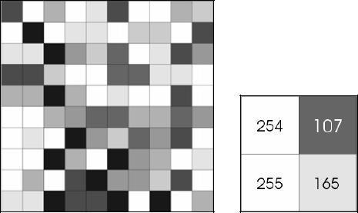

## Figure 5.2 Shades of gray

Gray scale can be represented by numbers between 0-255.One single image can be divided under many levels of gray color.

## 5.1.5 IMAGE ENHANCEMENT

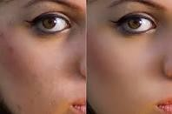

**Figure 5.3 original image and enhanced image**

Image enhancement is the improvement of digital image quality (wanted e.g. for visual inspection or for machine analysis), without knowledge about the source of degradation. Many different, often elementary and heuristic methods are used to improve images in some sense. Apart from geometrical transformations some preliminary grey level adjustments may be indicated, to take into account imperfections in the acquisition system. This can be done pixel by pixel, calibrating with the output of an image with constant brightness. Frequently space-invariant grey value transformations are also done for contrast stretching, range compression, etc. The critical distribution is the relative frequency of each grey value, the grey value histogram.

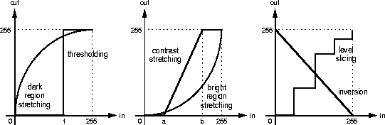

## Figure 5.4 The gray value histogram

The critical distribution is the relative frequency of each grey value, the grey value histogram.A second design goal, therefore, is image sharpening.

|  |  |  |
| --- | --- | --- |
| 5 | 6 | 7 |
| 4 | 8 | 0 |
| 3 | 2 | 1 |

## Figure 5.5 A 3x3 neighbourhood

All these operations need neighbourhood processing, viz. the output pixel is a function of some neighbourhood of the input pixels. we number the pixels in a 3x3 neighbourhood like

## MODULE DESCRIPTION

The following are the modules of the project along with the way they are implemented and that is planned with respect to the designed that system, while overcoming existing system and also providing the support for the future enhancement system. The implementation stage involves careful planning, investigation of the existing system and it’s constraints on implementation, designing of methods to achieve changeover and evaluation of changeover methods. There are totally five modules used in our project which is listed below. Each module has specific usage in the project and is description is given below followed by the list of modules,

1. Pre-processing
2. Feature Extraction
3. Classification
4. Matching

## PREPROCESSING

Image pre-processing and enhancement stage are the simplest categories in medical image processing. This stage is used for reducing image noise, highlighting edges, or displaying digital images. Some more techniques can be employed in medical image processing of coherent echo signals prior to image generation. The enhancement stage includes resolution enhancement, contrast enhancement. These are used to suppress noise and imaging of spectral parameters. After this stage, the medical image is converted into standard image without noise, film artifacts and labels.

Pre-processing indicates that the same tissue type may have a different scale of signal intensities for different images. Pre-processing functions involve the operations that are normally required prior to the main data analysis and extraction of information, and are generally grouped as radiometric or geometric corrections.

The pre-processing techniques such as Content Based model, Fiber tracking Method, Wavelets and Wavelet Packets, and Fourier transform technique are surveyed and analyzed in this section. Pushpaja et al. presented the Image pre-processing as a combination of three modules such as histogram equalization, edge detection and token matching. Sonali Patil and Udupi discussed the image is pre-processing by using median filter and followed by image segmentation was done in the image .Yadollahi et al. described the Median filter is one of simplest and most efficient approaches to remove “impulsive” or “salt & pepper” noise.

Conventional enhancement techniques mainly are the global and fix neighborhood techniques that may adapt to the global features or local features within a fix neighborhood, and they modify the images based only on global properties. The contract stretching techniques, histogram equalization, un-sharp masking, spatial filtering are the major techniques. Microcalcifications vary greatly in sizes and shapes, and the contrast between the ROIs and the surrounding tissues is varying greatly, therefore, mammograms cannot be enhanced by the global or fix-neighbourhood techniques due to their lack of adaptiveness.

Most of the conventional enhancement techniques enhanced not only the microcalcifications but also the background and noise. It will have the under enhancement and over-enhancement problems, i.e., some regions are under enhanced while some regions are over enhanced. Image enhancement methods inquire about how to improve the visual appearance of images from Mammogram Image, Computed Tomography scan; Positron Emission Tomography and the contrast enhancing breast image were linearly aligned. The enhancement activities are removal of film artifacts and labels, filtering the images. Conventional Enhancement techniques such as low pass filter, Median filter, Gabor Filter, Gaussian Filter, Prewitt edge-finding filter, Normalization Method are employable for this work.

## FEATURE EXTRACTION

A feature is an individual measurable property or characteristic of a phenomenon being observed. Choosing informative, discriminating and independent features is a crucial step for effective algorithms in pattern recognition, classification and regression. Features are usually numeric, but structural features such as strings and graphs are used in syntactic pattern recognition. The concept of "feature" is related to that of explanatory variable used in statistical techniques such as linear regression.

## CLASSIFICATION TECHNIQUES

Image classification is a complex process that may be affected by many factors. This chapter details supervised and unsupervised classification techniques. The emphasis is placed on the support vector machine classification approach and how this technique is used for improving classification accuracy.The major steps of image classification may include image pre- processing, feature extraction, selection of training samples, selection of suitable classification approaches, post-classification processing, and accuracy assessment.

The learning algorithms are broadly classified into supervised, unsupervised learning techniques. The distinction is drawn from how the learner classifies data. In supervised learning, the classes are pre-determined. These classes can be conceived of as a finite set, previously arrived at by a human. In practice, a certain classes of data will be labeled with these classifications.

The basic task of unsupervised learning is to develop classification labels automatically. Unsupervised algorithms seek out similarity between 112 pieces of data in order to determine whether that can be characterized as forming a group. These groups are termed clusters. Unsupervised classification, often called as clustering, the system is not informed how the pixels are grouped. The task of clustering is to arrive at some grouping of the data. One of the very common of cluster analysis is K-means clustering.

## MATCHING

Given a feature in I1, how to find the best match in I2?

1. Define distance function that compares two descriptors .
2. Test all the features in I2, find the one with min distance .

## CHAPTER 6 RESULTS AND OUTPUT

The developed output shows that whether the database containing the given image by prompting the messages as matched and unmatched.

## CODING

clc clear all close all

[fname,pname]=uigetfile('*.jpg','Select the Input Image for Matching/UnMatching')

aa1=imread(strcat(pname,fname)); figure,imshow(aa1)

title 'Input Image in RGB' if ndims(aa1)==2

aa = cat(3, aa1, aa1, aa1); else

aa=aa1; end

figure,imshow(aa)

title 'Input Image in GrayScale'

faceDetector = vision.CascadeObjectDetector;

shapeInserter =

vision.ShapeInserter('BorderColor','Custom','CustomBorderColor',[ 0 255 255]); I=aa;

bbox = step(faceDetector, I);

% Draw boxes around detected faces and display results I_faces = step(shapeInserter, I, int32(bbox)); figure,imshow(I_faces), title('Detected faces'); hj1=imcrop(I,bbox);

figure,imshow(hj1) imwrite(hj1,strcat('detected_face','.png')) if ndims(hj1)==3 seg_img=rgb2gray(hj1);

else

seg_img=(hj1); end

signal1 = seg_img;

%Feat = getmswpfeat(signal,winsize,wininc,J,'matlab');

%Features = getmswpfeat(signal,winsize,wininc,J,'matlab');

[cA1,cH1,cV1,cD1] = dwt2(signal1,'db4'); figure,imshow(uint8([cA1 cH1;cV1 cD1])) title 'First level DWT'

[cA2,cH2,cV2,cD2] = dwt2(cA1,'db4');

figure,imshow(uint8([cA2 cH2;cV2 cD2])) title 'Second level DWT' [cA3,cH3,cV3,cD3] = dwt2(cA2,'db4');

figure,imshow(uint8([cA3 cH3;cV3 cD3])) title 'Third level DWT'

DWT_feat = [cA3,cH3,cV3,cD3]; G = pca(DWT_feat);

whos DWT_feat whos G

g = graycomatrix(G);

stats = graycoprops(g,'Contrast Correlation Energy Homogeneity'); Contrast = stats.Contrast;

Correlation = stats.Correlation; Energy = stats.Energy;

Homogeneity = stats.Homogeneity; Mean = mean2(G); Standard_Deviation = std2(G); Entropy = entropy(G);

RMS = mean2(rms(G));

%Skewness = skewness(img) Variance = mean2(var(double(G))); a = sum(double(G(:)));

Smoothness = 1-(1/(1+a)); Kurtosis = kurtosis(double(G(:)));

Skewness = skewness(double(G(:)));

% Inverse Difference Movement m = size(G,1);

n = size(G,2); in_diff = 0; for i = 1:m

for j = 1:n

temp = G(i,j)./(1+(i-j).^2);

in_diff = in_diff+temp; end

end

IDM = double(in_diff);

%% Testing Features

feat = [Contrast,Correlation,Energy,Homogeneity, Mean, Standard_Deviation, Entropy, RMS, Variance, Smoothness, Kurtosis, Skewness, IDM];

%% Training Features load featernew

meas=feater;% training feature xdata = meas;

group = label;% category species= label; g1='Matched'; g2='UnMatched';

c1 = knnclassify(meas,meas,label); if strcmpi(hyu,g1)

helpdlg(' Matched') disp('Matched')

det=1

elseif strcmpi(hyu,g2) helpdlg('UnMatched') disp('UnMatched') det=0

else

return end

rloss = resubLoss(mdl) cvmdl = crossval(mdl); kloss = kfoldLoss(cvmdl)

resp1 = strcmp(label,g1); % resp = 1, if Y = 'b', or 0 if Y = 'g' pred = meas(:,11:13);

mdl1 = fitglm(pred,resp1,'Distribution','binomial','Link','logit'); scores1 = mdl1.Fitted.Probability;

[X1,Y1,T1,AUC1] = perfcurve(label,scores1,g1); figure,

plot(X1,Y1,'r')

legend('Matched') xlabel('False positive rate') ylabel('True positive rate') title('ROC for KNN')

hold on

resp2 = strcmp(label,g2); % resp = 1, if Y = 'b', or 0 if Y = 'g' pred = meas(:,11:13);

mdl2 = fitglm(pred,resp2,'Distribution','binomial','Link','logit'); scores2 = mdl2.Fitted.Probability;

[X2,Y2,T2,AUC2] = perfcurve(label,scores2,g2); figure,

plot(X2,Y2,'b') legend('Matched':'UnMatched') xlabel('False positive rate') ylabel('True positive rate')

indices = crossvalind('Kfold',label,18); cp = classperf(label,c1)

get(cp) cp.CorrectRate

## SCREENSHOTS

The below screenshots will explain the flow of output in each process.

## ORIGINAL IMAGE

The pre-processing includes series of operations performed on acquired input. And the below image describes the first ever process of system.

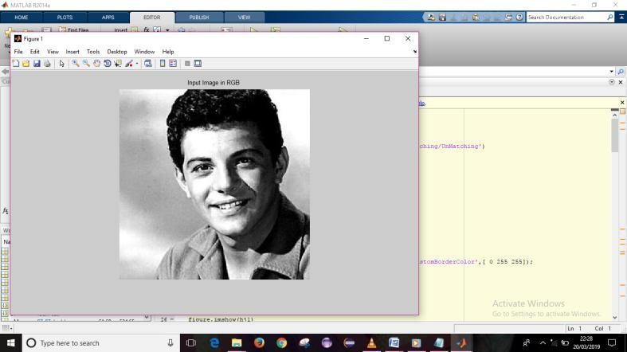

## Figure 6.1 ORIGINAL IMAGE

This is the first stage of our proposed system, image can be given as an input for pre-processing process.

## GRAY SCALE IMAGE

Frequently space-invariant gray value transformations are also done for contrast stretching, range compression, etc.

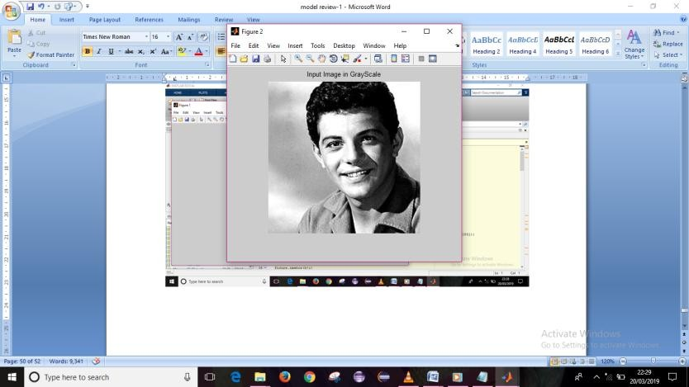

## Figure 6.2 GRAY SCALE IMAGE

It will change the image into a grayscale image for further processing.This Screenshot shows RGB to Grayscale conversion.

## DETECTED FACE BEFORE CROPPING

To reduce the space of working for feature extraction Cropping process will be held. To reduce the noise and workspace perform cropping on image.

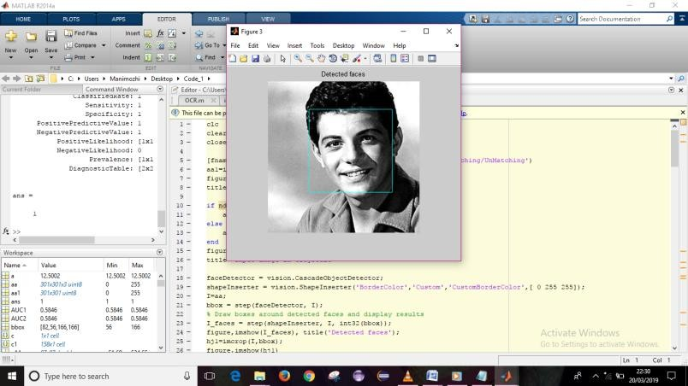

## Figure 6.3 DETECTED FACE BEFORE CROPPING

In pre-processing system, cropping also takes place. This screenshot shows extracting feature limit for cropping.

## IMAGE AFTER CROPPING

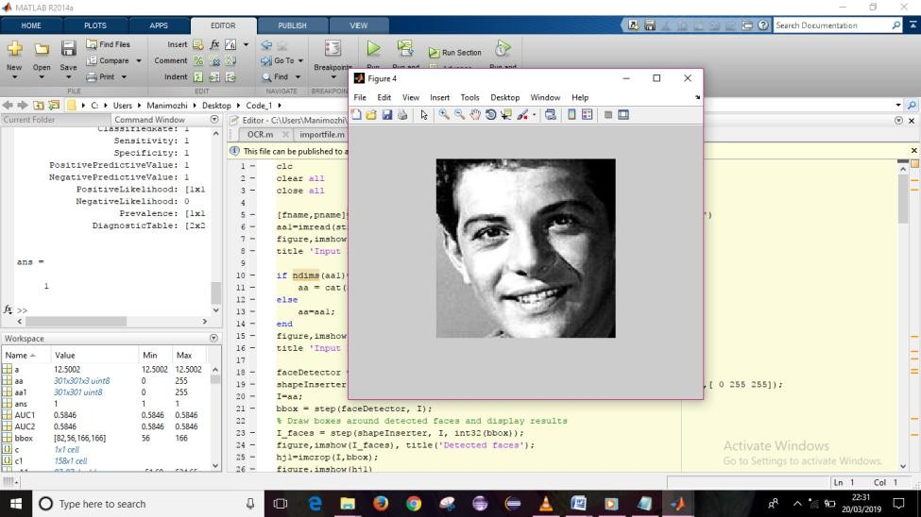

**Figure 6.4 IMAGE AFTER CROPPING**

This screenshot shows the image after cropping that is the last process of pre- processing. After this cropping process, pre-processing has completed.

## FIRST LEVEL DWT

A feature vector is an n-dimensional vector of numerical features that represent some object.

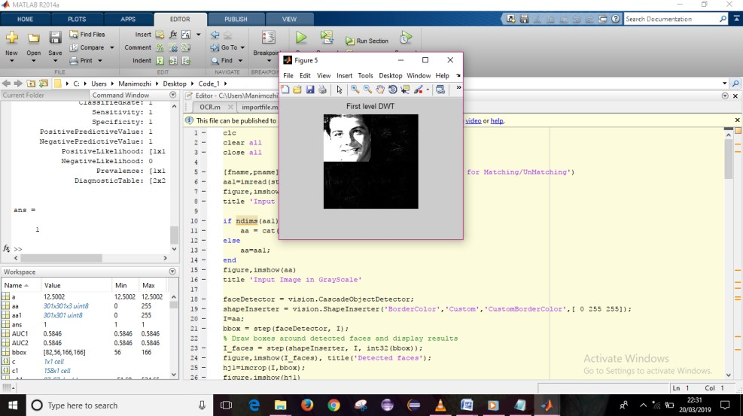

## Figure 6.5 FIRST LEVEL DWT

This is the first level of discrete wavelet transform, after pre-processing feature will be extracted using discrete wavelet transform.

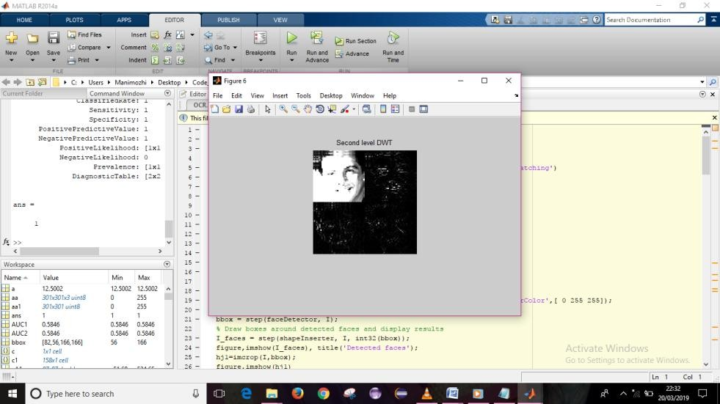

## Figure 6.6 SECOND LEVEL DWT

This is the second level of discrete wavelet transform, after pre-processing feature will be extracted using discrete wavelet transform.

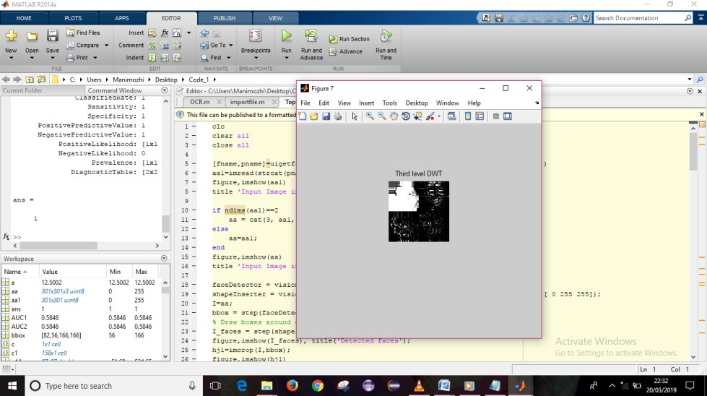

## Figure 6.7 THIRD LEVEL DWT

This is the third level of discrete wavelet transform, after pre-processing feature will be extracted using discrete wavelet transform.

## MATCHING OUTPUT

Matching Can handle the significant changes in illumination. It will be fast and efficient. Matching is the final process of our system, it can be called as classification.

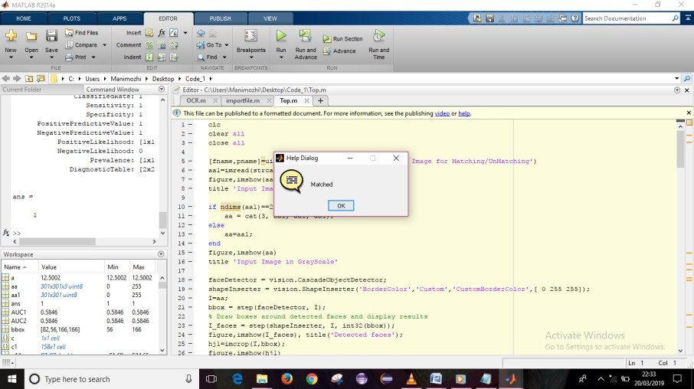

## Figure 6.8 MATCHING OUTPUT

This is the final result which is extracted from our designed that system. It will display the message as matched or unmatched.

## CHAPTER 7

**CONCLUSION AND FUTURE WORK**

From this project, we can conclude that Neural Network has time complexity, so we go for Principle component Analysis (PCA), Discrete Wavelet Transform(DWT) and Gray Level Co- Occurrence Matrix(GLCM). For more efficient solution we go for Support Vector Machine (SVM).This method makes the final outcome more efficient even if an image has different color and background. Our objective of this project is to detect the perfect face features. Using those features as an input to the classifier, we can identify whether the particular face in a large image database is available or not. If we find the exact face, then need to reply 1 else 0. Whereas the DWT decomposes an image into a set of basic functions called wavelets; decomposition is defined as the “resolution” of an image. The DWT then performs a multi-resolution analysis of a signal with localization in both time and frequency domains. Further work can be proceeded by reducing the time taken to read the input image. And also it can be made more efficient by making the Support Vector Machine processes.

## REFERENCES

* + - 1. Hemalatha, C., & Logashanmugam, E. (2018). Face Recognition Based on Dwt and PCA Feature Extraction Using Artificial neural network Classifier. Medico-Legal Update, 18(1), 531-537.
      2. Mukhedkar, M. M., & Powalkar, S. B. (2015, October). Fast face recognition based on wavelet transform on pca. In Energy Systems and Applications, 2015 International Conference on (pp. 761-764). IEEE.
      3. Coşkun, M., Uçar, A., Yıldırım, Ö., & Demir, Y. (2017, November). Face recognition based on convolutional neural network. In Modern Electrical and Energy Systems (MEES), 2017 International Conference on (pp. 376- 379). IEEE.
      4. Kim, K. I., Jung, K., & Kim, H. J. (2002). Face recognition using kernel principal component analysis. *IEEE signal processing letters*, *9*(2), 40-42.
      5. S. Asthana, n. Sharma, and r. Singh, "vehicle number plate recognition using multiple layer back propagation neural networks," international journal of computer technology and electronics engineering (ijctee), vol. 1, 2011.
      6. Bhonsale Tejas, Dhamal Omkar, Dhumal Rutuja, “Number Plate Recognition And Document Verification Using Feature Extraction OCR Algorithm ” vol 7,2017.
      7. L . Carrera, M. Mora, J. Gonzalez, and F. Aravena, “License plate detection using neural networks,” in Proc. IWANN, 2009, vol. 2, pp. 1248– 1255.
      8. M. I. Chacon and A. Zimmerman, “License plate location based on a dynamic PCNN scheme,” in Proc. Int. Joint Conf. Neural Netw., 2003, vol. 2, pp. 1195–1200.
      9. S.L. Chang, L.-S. Chen, Y.-C. Chung, and S.-W. Chen, “Automaticn license plate recognition,” IEEE Trans. Intell. Transp. Syst., vol. 5, no. 1, pp. 42–53, Mar. 2004.
      10. J . S . Chittode and R. Kate, “Number plate recognition using segmentation,” International Journal of Engineering Research & Technology, Vol. 1 Issue 9, November- 2012.

11.C. Chunyu, W. Fucheng, C. Baozhi and Z. Chen,” Application of image processing to the vehicle license plate recognition,” International Conference on Computer Science and Electronics Engineering, published by Allantis press, pp 2867-2869, 2013.

12. S. A. Daramola, e. Adetiba, a. Adoghe, j. Badejo, i. Samuel, and t. Fagorusi, "automaticvehicle identification system using license plate," international journal of engineering science and technology, vol. 3, pp. 17121719, 2011.

13.M. H. Dashtban and z. Dashtban, "a novel approach for vehicle license plate localization and recognition," international journal of computer applications, vol. 26, 2011.

14.M. Ibrahim, M. Shehata, and W. Badawy, “Automatic license plate recognition (ALPR): A state-of-the-art-review,” IEEE Trans. Circ. Sys. Video Tech., vol. 23, pp. 311-325, Feb. 2013.

15.N. K. Ibrahim, e. Kasmuri, n. A. Jalil, m. A. Norasikin, s. Salam, and m.

R. M. Nawawi, "license plate recognition (lpr): a review with experiments for malaysia case study," arxiv preprint arxiv:1401.5559, 2014.

1. Jobin K .V , “Automatic Number Plate Recognition system using modiﬁed Stroke Width Transform”,2014.
2. Junaid Ali Khan, Munam Ali Shah, Abdul Wahid, Muhammad Hassam Khan, Muhammad Bilal Shahid, “Enhanced Car Number Plate Recognition (ECNPR) system by improving efficiency in preprocessing steps”,2017.
3. P. Kanani, A. Gupta, D. Yadav, R. Bodade, and R.B. Pachori, “Vehicle license plate localization using wavelets”, Proceedings IEEE Conference on Information and Communication Technologies, Thuckalay, India, April 11-12, 2013.
4. O Khalifa, S Khan, R Islam and A Suleiman,” Malaysian vehicle license plate recognition,” The International Arab Journal of Information Technology, vol-4, no-4, pp 359-365, Oct 2007.

20.S. K. Kim, D. W. Kim, and H. J. Kim, “A recognition of vehicle license plate using a genetic algorithm based segmentation,” in Proc. Int. Conf. Image Process., 1996, vol. 1, pp. 661–664.

1. S. Kranthi, K. Pranathi, and A. Srisaila, “Automatic number plate recognition,” Int. J. Adv. Tech., vol. 2, pp. 408-422, July 2011.
2. G . C . Lekhana and R.Srikantaswamy,” Real time license plate recognition system,” International Journal of Advanced Technology & Engineering Research, Vol-2, Issue-4, pp 5-9, July 2012.
3. H . W. Lim and Y. H. Tay, “Detection of license plate characters in natural scene with MSER and SIFT unigram classifier,” in Proc. IEEE Conf. Sustainable Utilization Develop. Eng. Technol., 2010.
4. Madhusree Mondal, Parmita Mondal, and Nilendu Saha, “Automatic Number Plate Recognition Using CNN Based Self Synthesized Feature Learning”, vol 12, 2017.

25.H. Mahini, S. Kasaei, F. Dorri, and F. Dorri, “An efficient features-based license plate localization method,” Proceedings of 18th International Conference on Pattern Recognition, Hong Kong, 2006.

26.Rajshekhar Mukherjee, “A Robust Algorithm for Morphological, Spatial Image-Filtering and Character Feature Extraction and Mapping Employed for Vehicle Number Plate Recognition”,2017.

27.P.Reshma, "noise removal and blob detection approach for number plate identification," international journal of computer applications, vol. 47, pp. 1316, 2012.

28.S. Z. Wang and H. M. Lee, “Detection and recognition of license plate characters with different appearances,” in Proc. Conf. Intell. Transp. Syst., 2003.

1. Yoshihiro Shima, “Extraction of Number Plate Images Based on Image Category Classification Using Deep Learning”, vol 8,2016.
2. X . Zhang and S . Zhang , “A robust license plate detection algorithm based on multi-features,” in Proc. Int. Conf. Comput. Autom. Eng., 2010.